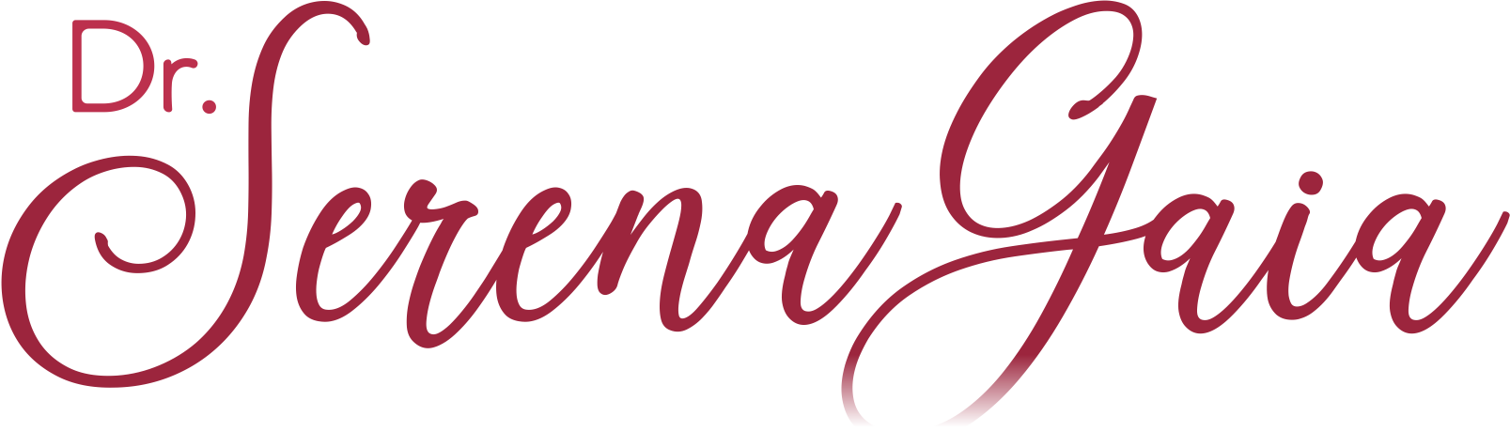
MEET YOUR PROGRAM LEADER
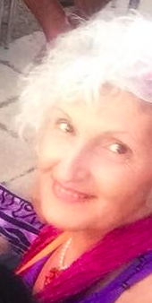  aka Serena Anderlini-D’Onofrio, PhD, is a teacher of #EcosexualLove. She is a leader in the ecosexual movement and an expert in the ecology of love. She is trained in Tantra, Tao, ISTA, ecosexual expression, and holistic bodywork. She has facilitated in Hawaii, Sweden, Italy, the USA, Puerto Rico and Estonia. |  | She is a sex-positive educator and has been involved with the Ecovillage Movement since 2005. She keynoted at the Ecosex Symposium in 2012 and at Loving More in 2007. She presented at GEN in 2017, 2018, and 2019.  An award-winning writer, activist, facilitator, scholar, filmmaker, professor, editor, and cultural theorist, she co-edited the collection Ecosexuality (2015), and co-directed Playa Azul I Love You (2016). “Her prophetic books,” including Eros (2006) and Gaia (2009), “have inspired readers around the world,” Dr. Susan M. Block has said.  Dr. SerenaGaia believes that “a world where it is safe to love is a world where it is safe to live,” and intends to create that world with her sacred activism.  Website: serenagaia.org  Facebook pages:  https://www.facebook.com/AlchemyToo/  https://www.facebook.com/GaiaBlessings/  https://www.facebook.com/drserenagaia  FILM: https://vimeo.com/user52221909  Contact:  dr.serenagaia@gmail.com  serena.anderlini@gmail.com  +39329 477 9406 (WhatsApp)

